Re-orderable Matrix and Parallel Coordinates Applied to Visualizing Data on Substitute teaching
Janette Cheng  Stanford University  janette.cheng@stanford.edu | Gloria Chua  Stanford University  cjmg@stanford.edu

ABSTRACT

Permission to make digital or hard copies of all or part of this work for personal or classroom use is granted without fee provided that copies are not made or distributed for profit or commercial advantage and that copies bear this notice and the full citation on the first page. To copy otherwise, or republish, to post on servers or to redistribute to lists, requires prior specific permission and/or a fee.
In this paper, we describe the design and implementation of a data visualization application around data related to the state of substitute teaching in the United States. The primary features of the web-based visualization are re-orderable matrices and parallel coordinates. The combination of these two modes of visualizations is not novel – however, contextualizing and understanding the requirements of substitute teaching with these tools is.

INTRODUCTION

Substitute Teaching Data
Among the many topics within the realm of education reform, the topic of substitute teaching is often neglected. There is limited press around the topic, and public information is limited to text-heavy governmental documents that are difficult to understand at first glance. [1 http://www.nea.org/home/14813.htm, 2 http://www.aps.edu/accountability-reporting/documents/2008-2009-publications/impact-of-substitue-teachers-on-student-achievement-research-brief-jan-2009 ] This presents a novel application for data visualization for a particularly niche data set.
Despite this, 10% of a student’s time in the classroom is spent with a substitute teacher. The presence of substitute teachers is crucial in maintaining and improving the quality of regular teachers as well – teachers are entitled to take time off for personal reasons, sick leave, or professional development, and substitute teachers are necessary to keep the classroom curriculum going. $4 billion (1% of the US Education Budget) is spent annually on substitute teaching, but little is publicly understood about the intricacies of substitute teaching, including teacher salary, requirements necessary to become a substitute teacher, and how these factors differ from state to state. Neither is substitute teaching understood in the context of the broader education system (e.g. how are substitute teacher salaries related to the state poverty levels, and how might these be in turn related to reading and writing scores?).

Target Audience
There are two main target audiences who might find understanding the intricacies of substitute teaching helpful. The first group is prospective substitute teachers, and the second group is a general audience interested in learning about topics in public education.
Our visualization aims to fulfill the needs of both audiences. In the Methodology section, we will describe the design principles and features that were employed to successfully achieve user goals.

RELATED WORK

Preliminary Design Choices
The main graphical components of our visualization consist of an interactive matrix to encode substitute teaching requirements, and a set of parallel coordinates to encode quantitative data such as teacher pay and reading/math scores for each state. One of the goals of our final visualization is to be able to identify larger trends within substitute teaching requirements, specifically similarities between states, and to tie these trends to quantitative measures. Thus, the majority of the past work we looked at was concerned either with re-orderable matrices or parallel coordinates.

Information on Substitute Teaching
Currently, two types of information on substitute teaching are available. The first, whose target audience is prospective substitute teachers, are school district websites that provide information on the steps and requirements to be a substitute teacher, and many of these school districts repeat similar state requirements, in formats that are text-heavy and difficult to navigate. (Fig 1 displays screenshots of such websites of selected school districts in the San Francisco Bay Area for reference.)
The second type is macro-level studies on substitute teaching, meant for a specialized audience, like a National Education Association study [1] or text-heavy research papers that are difficult to scan [2].
No known data visualization application for a general layperson audience has been created around this topic at the time of publication.

Re-orderable Matrices
Our work builds upon Jacque Bertin’s re-orderable matrices - data tables where numeric cell values have been replaced with appropriately sized ink blobs. [] The most important aspect of this particular visualization is that the viewer is capable of rearranging rows in order to group together rows that are visually similar, a task Bertin claims is natural and doesn’t require special skills.
Re-orderable matrices have been shown to be particularly suitable for pattern discovery in multi-dimensional applications, such as in archaeology [W. S. Robinson. A method for chronologically ordering archaeological deposits, volume 16. Am Antiq, 1951.] and ecology [Connor Upton, Gavin Doherty, and Myra ORegan. Usability evaluation of an ecological interface for process control health monitoring. Technical Report TCD-CS-2007-32, Department of Computer Science, Trinity College Dublin, 2007.].
We build on prior work that adds the ability to automatically group similar rows (manual grouping is time-consuming, especially for novice users). Siirtola and Mäkinen [H. Siirtola and E. Mäkinen. “Constructing and Reconstructing the Reorderable Matrix,” Inf Vis Information Visualization 4.1 (2005): 32-48.] suggest a “barycentric heuristic,” which given a matrix with binary cell values, treats it as an adjacency matrix and reorders the vertices in the resulting bipartite graph based on the averages of their adjacent vertices in the opposite vertex set. In two user studies, one with 12 and the other with 16 participants, it was found that this “correlation coefficient” view resulted in an approximate 60% improvement in time and accuracy over the classic manual user interface for the 16-participant study, and around 24% improvement in the 12-participant study.

Substitute teaching requirements are multivariate and each requirement is binary, therefore they are suitable to visualize using re-orderable matrices.

Parallel Coordinates
Our visualization also builds on prior work in parallel coordinates. We borrow principles established by Schneiderman on task taxonomy for high-level interaction design (Overview, Zoom, Filter, Details-on-demand, History, Extract) [B. Shneiderman, "The eyes have it: a task by data type taxonomy for information visualizations," Visual Languages, 1996. Proceedings., IEEE Symposium on, Boulder, CO, 1996, pp. 336-343.].

Siirtola and Raiha point out key issues to consider while designing our parallel coordinate interactions [H. Siirtola, K. Räihä, “Interacting with parallel coordinates,” Interact. Comput. (2006) 18 (6): 1278-1309]. They include obscured data relationships due to non-adjacencies of coordinate axes, and occlusion of data itself due to overlapping lines. Siirtola and Raiha also suggest a conventional technique of multi-dimensional brushing to select and filter data, and a hierarchical clustering method to abstract closely related data lines into a thicker one to address the occlusion problem.

Combining Re-orderable Matrices with Parallel Coordinates
Further work has also been done in linking these two data visualization structures in a single scheme. While reorderable matrices are good for identifying groups and classes within the data, correlations and anomalies are better displayed through parallel coordinates. A user study by Siirtola [H. Siirtola, "Combining parallel coordinates with the reorderable matrix," Coordinated and Multiple Views in Exploratory Visualization, 2003. Proceedings. International Conference on, 2003, pp. 63-74.] demonstrate that participants also generally found the reorderable matrix easier to use, and favored using the reorderable matrix as the input and confirming their observations by checking the parallel coordinates view.
Although we are looking to display different data sets in our visualization (parallel coordinates for quantitative data and a reorderable matrix for qualitative requirement data), the views can still be linked in specific ways that would enable this sort of workflow.

METHODOLOGY

Designing User Goals
As described in the introduction, our visualization has two main groups of audiences. We began by analyzing user goals of each group.
The first group is prospective substitute teachers, who might be most interested in a targeted understanding of the requirements and context for their specific state, and figuring out next steps (e.g. how to go about applying to be a substitute teacher).
The second group is a general audience who might be interested in public education, who might come across this particular visualization perhaps embedded in a news publication. This group is more likely to want to explore the data and pick up broader trends and relationships in the topic of substitute teaching. Some questions they might be interested in include (but are not limited to):
- Which states have the most stringent requirements to become a substitute teacher, and how might stringency be related to academic performance?
- How might a state’s substitute teacher salary be related to the socioeconomic context of a state, if at all?

Design Principles
We note here that the first user group is likely to prefer a more target visualization with state-specific details, while the second user group is likely more interested in macro-level trends.
We devised three main modes of data visualization that enables these contrasting user needs to be fulfilled.
- Re-orderable matrix: displays information regarding substitute teaching requirements for different types of substitute teachers (there may be more than 1 per state)
- Parallel coordinates: displays state-level contextual information around substitute teaching (e.g. mean annual salary, student academic performance, poverty level)
- Information cards: displays state-specific details for both requirements and contextual information, and actionable steps for prospective substitute teachers

Data Collection
Data on substitute teaching requirements were provided by Audra Hollingfield on behalf of Substantial, a non-profit initiative looking at ways to improve the recruitment, training and support of substitute teachers nationwide. The data has been curated from individual state websites and compiled.
Data on substitute teacher salaries came from the Bureau of Labor Statistics (http://www.bls.gov/oes/current/oes253098.htm). Reading and math scores of 4th and 8th graders are used as proxy indicators for student academic performance, and the data was taken from the National Assessment of Educational Progress [https://nces.ed.gov/nationsreportcard/reading/stateassessment.aspx]. Poverty level was represented by the percentage of students eligible for free and reduced lunch, provided by the National Center for Education Statistics [https://nces.ed.gov/programs/digest/d12/tables/dt12_046.asp]. All data is taken from the year of 2015.

Low to High Resolution Mockups
Need to write here

Implementation
We chose to implement the visualization in an interactive web-based application, supported by dataviz libraries builts upon d3.js. For reorderable matrices, we used the matrix.js library provided by _____ [], and for parallel coordinates, we used the parallel.js library provided by ____ [].

RESULTS
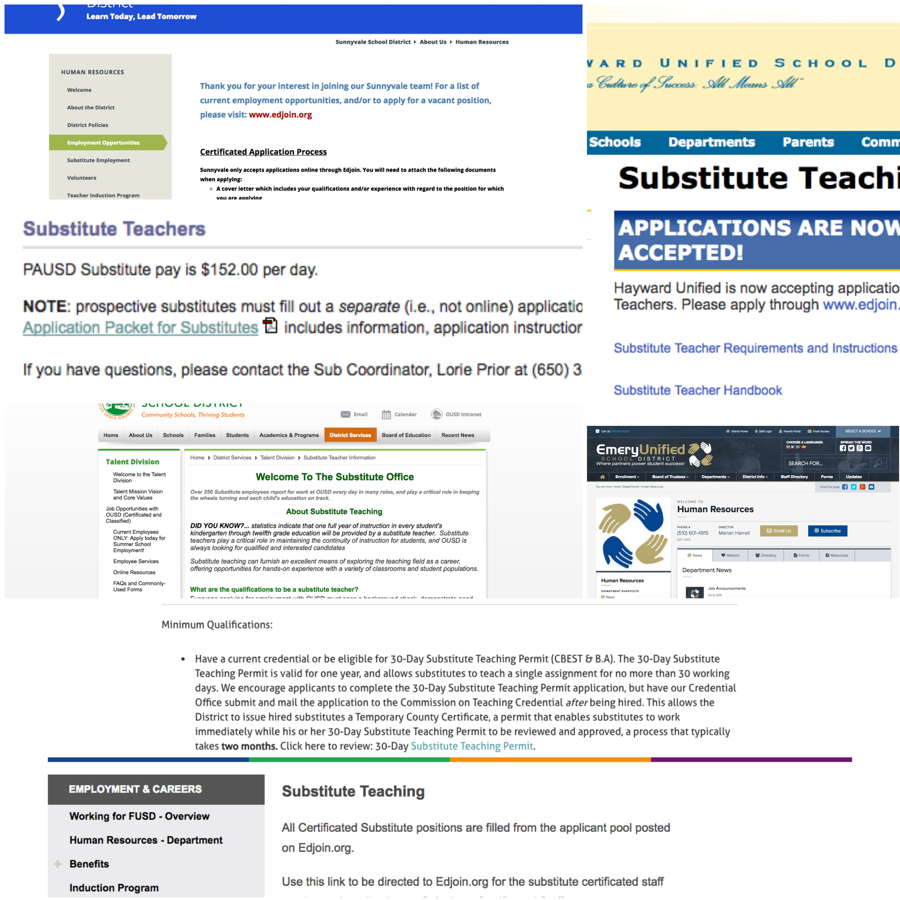
Figure 1. Screenshots of selected Bay Area school district websites’ substitute teaching pages (San Francisco, Sunnyvale, Hayward, Oakland, Palo Alto, Emery)

Final Visualization
Leave 3 cm (1.25 in.) of blank space for the copyright notice at the bottom of the left column of the first page. In this template a floating text box will automatically generate the required space. Note however that the text box is anchored to the ABSTRACT heading, so if that heading is deleted the text box will disappear as well.
Captions should be Times New Roman 9-point bold (Caption Style in this template file). They should be numbered (e.g., “Table 1” or “Figure 2”), centered and placed beneath the figure or table. Please note that the words “Figure” and “Table” should be spelled out (e.g., “Figure” rather than “Fig.”) wherever they occur.
Papers and notes may use color figures, which are included in the page limit; the figures must be usable when printed in black and white in the proceedings.
The paper may be accompanied by a short video figure up to five minutes in length. However, the paper should stand on its own without the video figure, as the video may not be available to everyone who reads the paper.

Inserting Images
Occasionally MS Word generates larger-than-necessary PDF files when images inserted into the document are manipulated in MS Word. To minimize this problem, use an image editing tool to resize the image at the appropriate printing resolution (usually 300 dpi), and then insert the image into Word using Insert | Picture | From File...

Table Style
The text of tables will format better if you use the special Table Text style (in this template file). If you do not use this style, then you may want to adjust the vertical spacing of the text in the tables. (In Word, use Format | Paragraph… and then the Line and Page Breaks tab. Generally, text in each field of a table will look better if it has equal amounts of spacing above and below it, as in Table 1.)

LANGUAGE, STYLE AND CONTENT
The written and spoken language of SIGCHI is English. Spelling and punctuation may use any dialect of English (e.g., British, Canadian, US, etc.) provided this is done consistently. Hyphenation is optional. To ensure suitability for an international audience, please pay attention to the following:
- Write in a straightforward style.
- Try to avoid long or complex sentence structures.
- Briefly define or explain all technical terms that may be unfamiliar to readers.
- Explain all acronyms the first time they are used in your text – e.g., “Digital Signal Processing (DSP)”.
- Explain local references (e.g., not everyone knows all city names in a particular country).
- Explain “insider” comments. Ensure that your whole audience understands any reference whose meaning you do not describe (e.g., do not assume that everyone has used a Macintosh or a particular application).
- Explain colloquial language and puns. Understanding phrases like “red herring” may require a local knowledge of English. Humor and irony are difficult to translate.
- Use unambiguous forms for culturally localized concepts, such as times, dates, currencies and numbers (e.g., “1-5- 97” or “5/1/97” may mean 5 January or 1 May, and “seven o’clock” may mean 7:00 am or 19:00). For currencies, indicate equivalences – e.g., “Participants were paid 10,000 lire, or roughly $5.”
- Be careful with the use of gender-specific pronouns (he, she) and other gendered words (chairman, manpower, man-months). Use inclusive language that is gender-neutral (e.g., she or he, they, s/he, chair, staff, staff-hours, person-years). See [6] for further advice and examples regarding gender and other personal attributes.
- If possible, use the full (extended) alphabetic character set for names of persons, institutions, and places (e.g., Grønbæk, Lafreniére, Sánchez, Universität, Weißenbach, Züllighoven, Århus, etc.). These characters are already included in most versions of Times, Helvetica, and Arial fonts.

Page Numbering, Headers and Footers
Please submit your anonymous version for reviewing with page numbers centered in the footer. These must be removed in the final version of accepted papers, as page numbers, headers, and footers will be added by the conference printers.

Producing and testing PDF files
We recommend that you produce a PDF version of your submission well before the final deadline. Besides making sure that you are able to produce a PDF, you will need to check that (a) the length of the file remains within the submission category’s page limit, (b) the PDF file size is 4 megabytes or less, and (c) the file can be read and printed using Adobe Acrobat Reader.
Test your PDF file by viewing or printing it with the same software we will use when we receive it, Adobe Acrobat Reader Version 7. This is widely available at no cost from [1]. Note that most reviewers will use a North American/European version of Acrobat reader, which cannot handle documents containing non-North American or non-European fonts (e.g. Asian fonts). Please therefore do not use Asian fonts, and verify this by testing with a North American/European Acrobat reader (obtainable as above). Something as minor as including a space or punctuation character in a two-byte font can render a file unreadable.

Blind Review
For archival submissions, CHI requires a “blind review.” To prepare your submission for blind review, remove author and institutional identities in the title and header areas of the paper. You may also need to remove part or all of the Acknowledgments text. Further suppression of identity in the body of the paper and references is left to the authors' discretion. For more details, see the submission guidelines and checklist for your submission category.

Conclusion
It is important that you write for the SIGCHI audience. Please read previous years’ Proceedings to understand the writing style and conventions that successful authors have used. It is particularly important that you state clearly what you have done, not merely what you plan to do, and explain how your work is different from previously published work, i.e., what is the unique contribution that your work makes to the field? Please consider what the reader will learn from your submission, and how they will find your work useful. If you write with these questions in mind, your work is more likely to be successful, both in being accepted into the Conference, and in influencing the work of our field.

ACKNOWLEDGMENTS
We thank CHI, PDC and CSCW volunteers, and all publications support and staff, who wrote and provided helpful comments on previous versions of this document. Some of the references cited in this paper are included for illustrative purposes only.

REFERENCES
- Adobe Acrobat Reader 7. http://www.adobe.com/products/acrobat/.
- Anderson, R.E. Social impacts of computing: Codes of professional ethics. Social Science Computing Review 10, 2 (1992), 453-469.
- How to Classify Works Using ACM’s Computing Classification System.
http://www.acm.org/class/how_to_use.html.
- Klemmer, R.S., Thomsen, M., Phelps-Goodman, E., Lee, R. and Landay, J.A. Where do web sites come from? Capturing and interacting with design history. In Proc. CHI 2002, ACM Press (2002), 1-8.
- Mather, B.D. Making up titles for conference papers. Ext. Abstracts CHI 2000, ACM Press (2000), 1-2.
- Schwartz, M. Guidelines for Bias-Free Writing. Indiana University Press, Bloomington, IN, USA, 1995.
- Zellweger, P.T., Bouvin, N.O., Jehøj, H., and Mackinlay, J.D. Fluid Annotations in an Open World. Proc. Hypertext 2001, ACM Press (2001), 9-18.

The columns on the last page should be of approximately equal length.

Note that the items in this bulleted list were formatted using the Bullet Style (in this template file).

